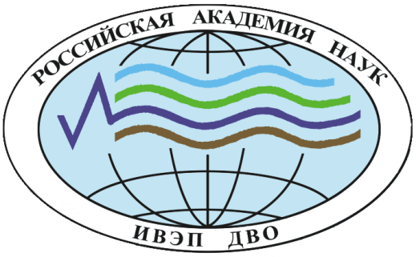

FEDERAL STATE-FUNDED INSTITUTION OF SCIENCE

Institute of Water and Ecology Problems
Far Eastern Branch of the Russian Academy of Sciences

FIRST LETTER OF INFORMATION

VII Druzhinin’s Readings

All-Russian conference with international participation
Dedicated to the 50th anniversary of the Institute of Water and Ecology Problems, FEB RAS

Natural hazards, modern environmental risks and ecosystem resilience

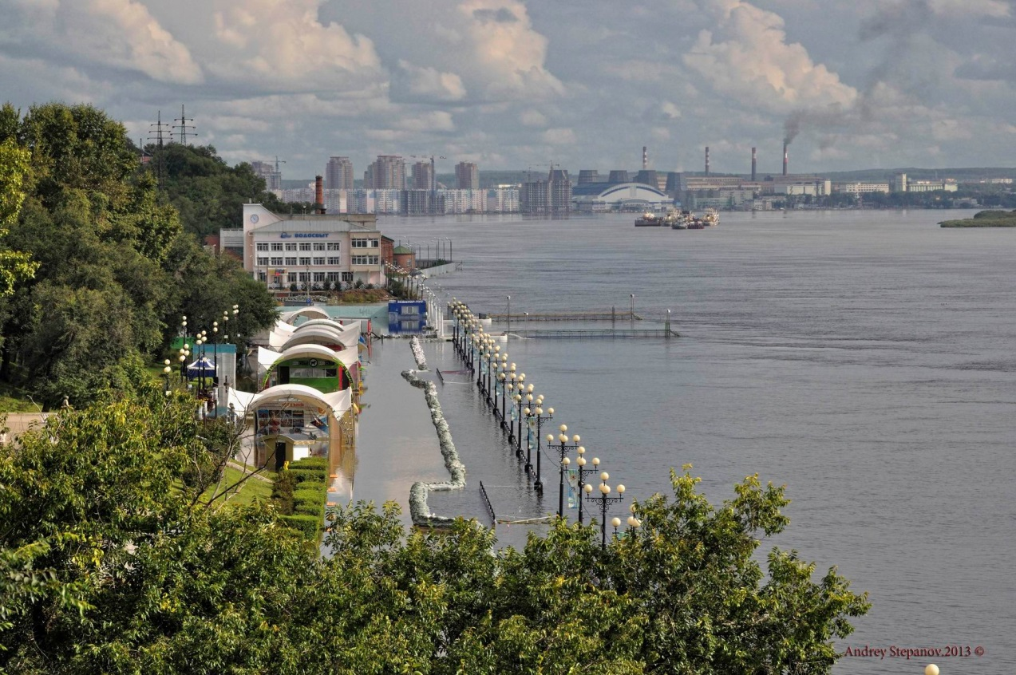

October 2-5, 2018
Khabarovsk

Dear colleagues!
The Institute of Water and Ecology Problems of the Far Eastern Branch of the Russian Academy of Sciences holds the All-Russian Scientific Conference with international participation of the VII Druzhinin’s Readings dedicated to the 50th anniversary of the Institute of Water and Ecology Problems, FEB RAS, which will be held on October 2-5, 2018.

THE MAIN DIRECTIONS OF THE CONFERENCE

- Natural and man-made hazards and their manifestations in ecosystems;
- Environmental risk: methodology and methods for assessing pollution of natural ecosystems;
- Regional features of the water resources formation;
- Biodiversity: challenges and prospects for preservation;
- Regional environmental management and environmental protection;
- Transboundary water and environmental problems;

Organizing Committee
Chairman: B. Voronov, corr.-member of RAS, IWEP FEB RAS.
Vice-chairmen: V. Kim, Ph.D. (Geography), IWEP FEB RAS.
Executive secretary: D. Andreyeva, IWEP FEB RAS.
Technical Secretary: Ya. Dugayeva, IWEP FEB RAS.
Members of the Organizing Committee:
L. Kondrat’yeva, Dr.Sc. (Biology), IWEP FEB RAS,
V. Kulakov, Dr.Sc. (Geology and Mineralogy), IWEP FEB RAS,
Z. Mirzekhanova, Dr.Sc. (Geography), IWEP FEB RAS,
N. Ryabinin, Dr.Sc. (Biology), IWEP FEB RAS,
S. Schlotgauer, Dr.Sc. (Biology), IWEP FEB RAS,
G. Kharitonova, Dr.Sc. (Biology), IWEP FEB RAS,
E. Koshkin, Ph.D. (Biology), IWEP FEB RAS,
V.Shesterkin, Ph.D. (Geography), IWEP FEB RAS,
V. Chakov, Ph.D. (Biology), IWEP FEB RAS,
D. Kurenschikov, Ph.D. (Biology), IWEP FEB RAS,
A. Ostroukhov, Ph.D. (Geography), IWEP FEB RAS,
V. Bardyuk, Deputy Minister of Natural Resources of the Khabarovsk Territory,
A. Makarov, Head of the Amur basin water management,
A. Gavrilov, Head of the Department of Roshydromet for the Far Eastern Federal District,
V. Parshin, Head of FSBI "Far East Administration of the Hydrometeorological Service"

Program Committee
Chairman: B. Voronov, corr.-member of RAS, IWEP FEB RAS.
Vice-chairmen: M. Kryukova, Dr.Sc. (Biology), IWEP FEB RAS.
Members of the Program Committee:
P. Baklanov, academician, ITG FEB RAS,
A. Makhinov, Dr.Sc. (Geography), IWEP FEB RAS,
I. Rasskazov, Dr.Sc. (Engineering), MI FEB RAS,
V. Ermoshin, Ph.D. (Geography), ITG FEB RAS,
V. Kalashnikov, Dr.Sc. (Economics), Deputy Prime Minister - Minister of Economic Development and External Relations of the Khabarovsk Territory,
A. Kuznetsova, Dr.Sc. (Education), Minister of Education and Science of the Khabarovsk Territory,
A. Ermolin, Minister of Natural Resources of the Khabarovsk Territory,
Liu Shuguang, Tongji University (China),
Sambuu Gantomur, Mongolian State University of Science and Technology (Mongolia),
Takayuki Shiraiwa, Institute of Low Temperature Science, Hokkaido University (Japan),
Kwansue Jung, Chungnam National University (South Korea),
Battogtokh Dorigotov, Director of the Institute of Geography and Geoecology, Mongolian Academy of Sciences
Tsao Xin, Consul for Science and Technology (General Consulate of the PRC),
Dong Suocheng, Leading Professor, Dr., Director of Regional Eco-economics Research and Planning Center, Director of Resource Economics and World Resource Research, Center Institute of Geographic Sciences and Natural Resource Research, CAS, Vice Director of Tourism Research and Planning & Design Center, CAS
Pingyu Zhang, Ph.D. Professor, Vice Director of the Northeast Institute of Geography and Agroecology, CAS (Changchun, PRC).
Changley Dai, Ph.D. (Hydrology and Water Resources), Director of the Institute of Groundwater in Cold Region, Heilongjiang University School of Hydraulic and Electric-power, Heilongjiang University, (Heilongjiang, Harbin)

The application form for participation must be sent to the Organizing Committee by April 15, 2018 by e-mail drujininskie.chtenia-2018@yandex.ru with the topic "Druzhin’s readings_7".
Please do not delay the sending of the application, since we are applying for a grant from the RFBR for the conference, in which it is necessary to indicate all full-time and correspondence participants of the conference with the title of the reports.

Application form
Surname
Name
Patronymic
Place of work, position
Scientific degree, rank
Phone number (with area code)
Е-mail
Address
Co-author (s)
Direction
Title of the report
Year of birth
Form of participation (full-time, correspondence)
Report (oral, poster)
Consent to the processing of personal data and the publication of reports in the conference proceedings (yes, no)

Requirements for the design of materials.
The publication accepts texts with a volume of up to 4 full pages (including figures, tables and list of literature alphabetically (no more than 5 links)), A4 format. The text should be printed on the computer with intervals of 1 and with the font Times New Roman 11 pt. References to the literature in the text - the number from the list in square brackets. The indentation is 1.25 cm, the margins are 25 mm on all sides. The title of the article should be in capital letters in bold type, the surname and initials of the authors, the full name of the organization are drawn up with an equalization in width in Russian and English. The article is accompanied by a short abstract in English with a volume of not more than 700 characters with spaces.
No more than 2 articles are accepted from each author (including in co-authorship).
Materials prepared without observing the rules for authors are not allowed for printing. The Organizing Committee reserves the right to reject works that do not correspond to the topics of the conference.
Materials of the reports should be submitted no later than July 31, 2018. The publication of the materials is planned in electronic form with the assignment of the ISBN number, posting in the RSCI system and on the site of the Institute of Water and Ecology Problems FEB RAS.

The registration fee, which is 150 dollars, must be paid before August 15, 2018.
Organizational fee guarantees participation in meetings, receipt of materials, individual sets of information documents and coffee breaks.
Bank details will be indicated in the second letter of information.

PRELIMINARY PROGRAM OF THE CONFERENCE:
October 2, Tuesday | Arrival of participants, registration of participants
October 3, Wednesday | Registration of participants  Conference
October 4, Thursday | Conference
October 5, Friday | Scientific excursion, lunch.

Contact Information:
680000, Khabarovsk, Dikopoltseva St., 56, IWEP FEB RAS.
(4212)-32-57-55, ivep@ivep.as.khb.ru – Alexey Makhinov,
(4212)-21-08-46, kim@ivep.as.khb.ru – Vladimir Kim,
(924)-307-83-05, drujininskie.chtenia-2018@yandex.ru – Diana Andreyeva,
(914)-415-36-68, drujininskie.chtenia-2018@yandex.ru – Yana Dugayeva.

Important dates:
before April 15 - acceptance of applications;
before July 31 - receipt of materials;
before August 15 - payment of organizational fees;
October 2-5 - conference.

